**ABSTRACT**

A smart building is a residential or commercial building with greatly reduced energy needs through efficiency gains such that the balance of energy needs can be supplied with renewable technologies. Despite the excitement over the phrase “smart energy,” we lack a common definition, or even a common understanding, of what it means. In this project, we use a sample of current generation low-energy buildings to explore the concept of smart energy: what it means, why a clear and measurable definition is needed, and how we have progressed toward the smart building goal.

The way the smart energy goals are defined affects the choices designers make to achieve this goal and whether they can claim success. The smart building definition can emphasize demand-side or supply strategies and whether fuel switching and conversion accounting are appropriate to meet a smart building goal. Four well-documented definitions smart site energy, smart source energy, smart energy costs, and smart energy emissions are studied pluses and minuses of each are discussed. These definitions are applied to a set of low-energy buildings for which extensive energy data are available. This study shows the design impacts of the definition used for smart building and the large difference between definitions. It also looks at sample utility rate structures and their impact on the smart energy scenarios.

**CHAPTER I**

**INTRODUCTION**

**INTRODUCTION**

**1.1 Introduction**

Buildings have a significant impact on energy use and the environment. Commercial and residential buildings use almost 40% of the primary energy and approximately 70% of the electricity in the United States (EIA 2005). The energy used by the building sector continues to increase, primarily because new buildings are constructed faster than old ones are retired. Electricity consumption in the commercial building sector doubled between 1980 and 2000, and is expected to increase another 50% by 2025 (EIA 2005). Energy consumption in the commercial building sector will continue to increase until buildings can be designed to produce enough energy to offset the growing energy demand of these buildings. Toward this end, the U.S. Department of Energy (DOE) has established an aggressive goal to create the technology and knowledge base for cost-effective zero-energy commercial buildings (Green Building) by 2025.

In concept, a net Smart Building is a building with greatly reduced energy needs through efficiency gains such that the balance of the energy needs can be supplied by renewable technologies. Despite our use of the phrase “smart energy,” we lack a common definition or a common understanding of what it means. In this project, we use a sample of current generation low-energy buildings to explore the concept of zero energy what it means, why a clear and measurable definition is needed, and how we have progressed toward the Smart Building goal. At the heart of the Smart Building concept is the idea that buildings can meet all their energy requirements from low-cost, locally available, nonpolluting, renewable sources. At the strictest level, a Smart Building generates enough renewable energy on site to equal or exceed its annual energy use. The following concepts and assumptions have been established to help guide definitions for Smart Building.

**1.2 Objective**

The main objective of this project is to study and analysis the existing building and also to give an overview on an existing building to make it a perfect Smart Energy Building.

**1.3 Organization of report**

The report consists of five chapters. This chapter’s divides into subsections so as to get exact idea of system in simple way.

The first chapter is introduction. This chapter discusses about background, objective and scope of the project.

Chapter 2 is project overview. It discusses more on theory.

Chapter 3 is system development it discusses on hardware and software development of this project.

Chapter 4 is about result and analysis it is all about project testing and result.

Chapter 5 is conclusion, it will discuss about conclusion and further work proposal of project.

**CHAPTER II**

**LITERATURE REVIEW**

**LITERATURE REVIEW**

**2.1 Literature review**

With the Green Building concept gaining in popularity the literature on zero energy/emission buildings is also hasty growing. Most of the publication focuses on documenting different Green Building demonstration projects; however, a number of documents have significantly contributed to the discussion of understanding and defining Green Building concept. One of those milestones is the report written by Torcellini, et al. in 2006. The authors point out that despite the exciting phrase of ‘zero energy’, Green Building definition often lacks a clear and commonly understandable explanation of what this term actually means. Torcellini, et al (2006) indicate that the definition of Green Building concept can be constructed in several ways, depending on the project goals, intentions of the investor, concern about the climate changes and greenhouse gas emissions or finally the energy costs. Taking into consideration all the above mentioned scenarios Torcellini, et al. (2006) distinguishes and highlight advantages and disadvantages of four most commonly used definitions:

1. **Smart Site Energy**: A site GREEN BUILDING produces at least as much energy as it uses in a year, when accounted for at the site.
2. **Smart Source Energy:** A source GREEN BUILDING produces at least as much energy as it uses in year, when accounted for at the source. Source energy refers to the primary energy used to generate and deliver the energy to the site. To calculate a building’s total source energy, imported and exported energy is multiplied by the appropriate site-to-source conversion multipliers.
3. **Smart Energy Costs:** In a cost GREEN BUILDING, the amount of money the utility pays the building owner for the energy the building exports to the grid isat least equal to the IEA SHC/ECBCS Task 40/Annex amount the owner pays the utility for the energy services and energy used over the year.
4. **Smart Energy Emissions:** A net-zero emissions building produces at least as much emissions-free renewable energy as it uses from emissions-producing energy sources.

The distinction between different GREEN BUILDING definitions made by Torcellini, et al. (2006) is further discussed in various publications “The Potential Impact of Zero Energy Homes”, (2006), Torcellini, et al. *(2006), “Centerline”, (2008), Noguchi, et al. (2008), Kilkis, (2007), Voss, (2008), Kilkis, (2007) in his review on GREEN BUILDING definitions, takes slightly another direction then Torcellini, et al. (2006). He indicates that in balancing the ‘zero’ both quantity and quality (energy) of energy should be taken into consideration. Kilkis explains that “although GREEN BUILDING definition seems logical, it falls short recognize the importance of energy in assessing the complete impact of buildings on the environment. For example if a GREEN BUILDING is connected to a district energy system and receives high temperature heat as well as electrical energy and provides heat in the same quality at a lower temperature and at the same quantity of electrical energy to the district, the building is not balancing the energy of heat it receives and provides. This GREEN BUILDING is still impacting the environment because the negative energy balance must be made up by the district at a cost of additional fuel spending and harmful emission even though energy amounts of the heat and power flow across the building district boundary are balanced… If the district generates power in the thermal power plant, and the GREEN BUILDING generates electric power in a micro-combined heat and power (CHP) unit, and or by using wind turbine, all have different environmental impacts and energy”.

**CHAPTER III**

**HARDWARE DESCRIPTION AND PROJECT REVIEW**

**HARDWARE DESCRIPTION AND PROJECT OVERVIEW**

**3.1 Transformer**

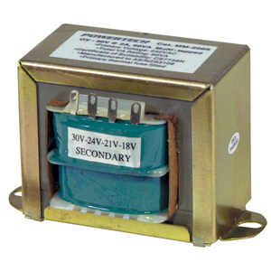

Step-down transformer is one whose secondary voltage is less than its primary voltage. It is designed to reduce the voltage from the primary winding to the secondary winding. This kind of transformer “steps down” the voltage applied to it.

Fig. 3.1 Step-down Transformer

As a step-down unit, the transformer converts high-voltage, low-current power into low-voltage, high-current power. The larger-gauge wire used in the secondary winding is necessary due to the increase in current. The primary winding, which doesn’t have to conduct as much current, may be made of smaller-gauge wire.

* 1. **Filter**

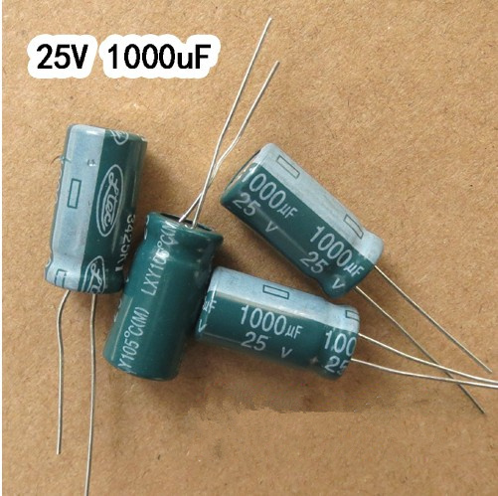

Fig 3.2 Electrolytic Capacitor

An electrolytic capacitor is a sort of capacitor that utilizes an electrolyte to obtain greater capacitance than the other type of capacitors. An electrolyte is a gel or fluid in which concentration of ions is very high.

* 1. **LDR**

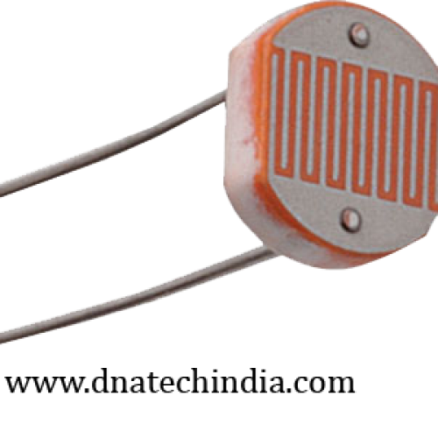

Fig.3.3 LDR

LDRs or Light Dependent Resistors are very useful especially in light/dark sensor circuits. As the amount of light falling on this LDR increases, its resistance decreases. Light Dependent Resistor is suitable for use in projects which require a device or circuit to be automatically switched on or off in darkness or light.The light detector itself is just 12mm in diameter with a lens and epoxy sealed metal package.

**3.4 Concept road system design**

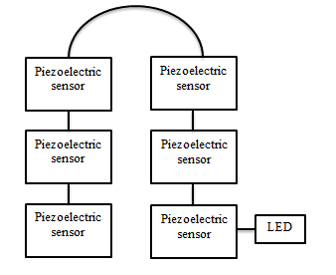

Fig.3.4 Design of road track

As shown in fig. we have implemented a design using six piezoelectric sensors connected or placed in parallel view. It creates electricity (energy) when a person walks on that area. Piezoelectric sensor senses the pressure and creates energy. And simultaneously LED will glow on when pressure detected on piezoelectric sensor.

**CHAPTER IV**

**PRIOJECT OVERVIEW**

**PROJECT OVERVIEW**

**4.1 Energy needed for the house**

In design condition, passive solar gain will cover 40% of house heating, internal sources 28%, active solar 21% and solar photovoltaic 11%.

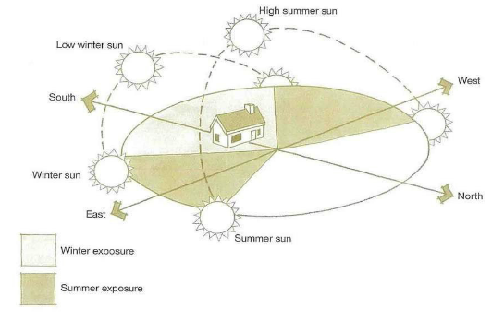

Fig 4.1 House Orientation w.r.t weather

**4.2 Strategies To Achieve Smart Energy**

Early in the project, the owner and the project team decided to pursue the goal of smart (purchased) energy Consumption as the only way to achieve a near-zero operating cost. Among a multitude of integrated design systems, certain design features and analyses proved especially instrumental to achieving the project’s ambition energy goals.

In general, these elements can be grouped into four broad categories:

* Energy Modelling.
* Mechanical Systems.
* Building Envelope.
* Renewable Energy.

**CHAPTER V**

**METHODOLOGY**

**METHODOLOGY**

**5.1 Renewable Energy**

The project utilizes and on-site 8.9 kilowatt photovoltaic solar panel array mounted atop an exposed wood structure.The result is an outdoor Learning PowerPavilionthat uses the solar panels as a means of shelter while it produces clean, renewable energy. The photovoltaic solar panels were not located on the roof due to solar access considerations. Rather, the array was showcased via the adjacent Learning Power Pavilion. Due to the openness ofthe wood-framed structure, double-sided solar panels employed that have the ability to generate electricity from both sides. The back side of the panels generates electricity from ambient light. that is reflected off of the light concrete slab floor of the pavilion. Thus, more power is generated than if conventional photovoltaic panels were mounted atop the library’s roof.

**5.2 Components of SMART BUILDING**

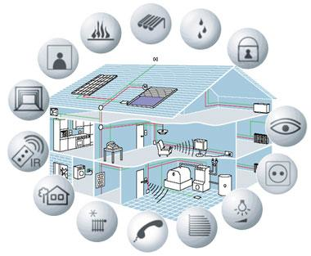

Fig 5.2 Components of Smart Building

**5.3 Solar Energy**

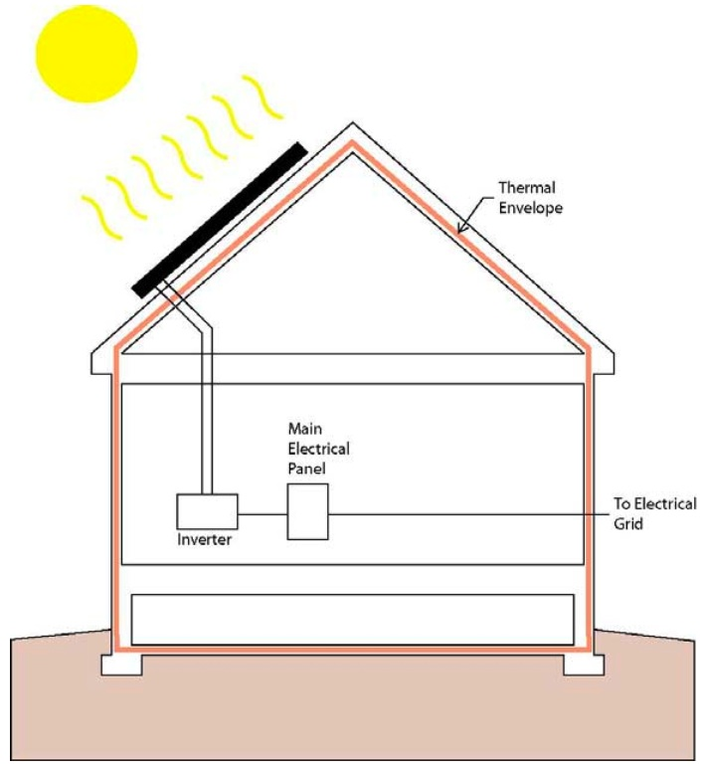

Fig 5.3 Solar Energy

Solar energy is radiant [light](http://en.wikipedia.org/wiki/Light) and [heat](http://en.wikipedia.org/wiki/Heat) from the [sun](http://en.wikipedia.org/wiki/Sun) harnessed using a range of ever-evolving technologies such as [solar heating](http://en.wikipedia.org/wiki/Solar_heating), [solar photovoltaic](http://en.wikipedia.org/wiki/Solar_photovoltaics), [solar thermal energy](http://en.wikipedia.org/wiki/Solar_thermal_energy), [solar architecture](http://en.wikipedia.org/wiki/Solar_architecture) and [artificial photosynthesis](http://en.wikipedia.org/wiki/Artificial_photosynthesis) It is an important source of [renewable energy](http://en.wikipedia.org/wiki/Renewable_energy) and its technologies are broadly characterized as either [passive solar](http://en.wikipedia.org/wiki/Passive_solar) or [active solar](http://en.wikipedia.org/wiki/Active_solar) depending on the way they capture and distribute solar energy or convert it into [solar power](http://en.wikipedia.org/wiki/Solar_power). Active solar techniques include the use of [photovoltaic systems](http://en.wikipedia.org/wiki/Photovoltaic_system), [concentrated solar power](http://en.wikipedia.org/wiki/Concentrated_solar_power) and [solar water heating](http://en.wikipedia.org/wiki/Solar_water_heating) to harness the energy. Passive solar techniques include orienting a building to the Sun, selecting materials with favorable [thermal mass](http://en.wikipedia.org/wiki/Thermal_mass) or light dispersing properties, and designing spaces that [naturally circulate air](http://en.wikipedia.org/wiki/Ventilation_(architecture)).

In 2011, the [International Energy Agency](http://en.wikipedia.org/wiki/International_Energy_Agency) said that "the development of affordable, inexhaustible and clean solar energy technologies will have huge longer-term benefits. It will increase countries’ energy security through reliance on an indigenous, inexhaustible and mostly import-independent resource, enhance [sustainability](http://en.wikipedia.org/wiki/Sustainability), reduce pollution, lower the costs of mitigating global, and keep [fossil fuel](http://en.wikipedia.org/wiki/Fossil_fuel) prices lower than otherwise. These advantages are global. Hence the additional costs of the incentives for early deployment should be considered learning investments; they must be wisely spent and need to be widely shared".

The Earth receives 174 [peta watts](http://en.wikipedia.org/wiki/Orders_of_magnitude_(power)#petawatt_.281015_watts.29) (PW) of incoming solar radiation ([insolation](http://en.wikipedia.org/wiki/Insolation)) at the upper [atmosphere](http://en.wikipedia.org/wiki/Earth%27s_atmosphere) Approximately 30% is reflected back to space while the rest is absorbed by clouds, oceans and land masses. The [spectrum](http://en.wikipedia.org/wiki/Electromagnetic_spectrum) of solar light at the Earth's surface is mostly spread across the [visible](http://en.wikipedia.org/wiki/Visible_light) and [near-infrared](http://en.wikipedia.org/wiki/Near-infrared) ranges with a small part in the [near-ultraviolet](http://en.wikipedia.org/wiki/Near-ultraviolet).

Earth's land surface, [oceans](http://en.wikipedia.org/wiki/Ocean) and atmosphere absorb solar radiation, and this raises their temperature. Warm air containing evaporated water from the oceans rises, causing [atmospheric circulation](http://en.wikipedia.org/wiki/Atmospheric_circulation) or [convection](http://en.wikipedia.org/wiki/Convection). When the air reaches a high altitude, where the temperature is low, water vapor condenses into clouds, which rain onto the Earth's surface, completing the [water cycle](http://en.wikipedia.org/wiki/Water_cycle). The [latent heat](http://en.wikipedia.org/wiki/Latent_heat) of water condensation amplifies convection, producing atmospheric phenomena such as [wind](http://en.wikipedia.org/wiki/Wind), [cyclones](http://en.wikipedia.org/wiki/Cyclone) and [anti-cyclones](http://en.wikipedia.org/wiki/Anti-cyclone). Sunlight absorbed by the oceans and land masses keeps the surface at an average temperature of 14 °C.[[6]](http://en.wikipedia.org/wiki/Solar_energy#cite_note-6) By [photosynthesis](http://en.wikipedia.org/wiki/Photosynthesis) green plants convert solar energy into [chemical energy](http://en.wikipedia.org/wiki/Chemical_energy), which produces food, wood and the [biomass](http://en.wikipedia.org/wiki/Biomass) from which fossil fuels are derived.

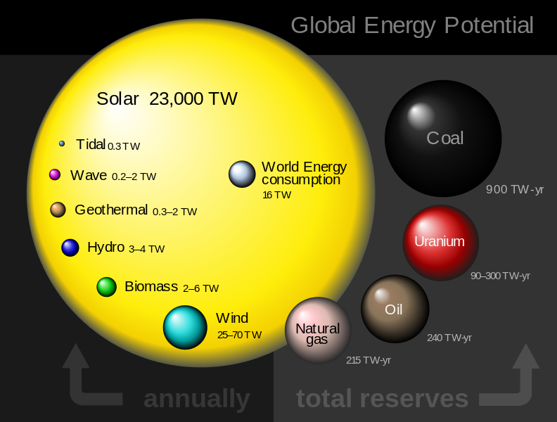

Fig 5.3.1 Global Energy Potential

The total solar energy absorbed by Earth's atmosphere, oceans and land masses is approximately 3,850,000 [exajoules](http://en.wikipedia.org/wiki/Joule#Multiples) (EJ) per year. In 2002, this was more energy in one hour than the world used in one year.Photosynthesis captures approximately 3,000 EJ per year in biomass the technical potential available from biomass is from 100–300 EJ/year. The amount of solar energy reaching the surface of the planet is so vast that in one year it is about twice as much as will ever be obtained from all of the Earth's non-renewable resources of coal, oil, natural gas, and mined uranium combined, Solar energy can be harnessed at different levels around the world, mostly depending on distance from the equator.

**5.3.1 Electricity production using sun**

Solar power is the conversion of sunlight into [electricity](http://en.wikipedia.org/wiki/Electricity), either directly using [photovoltaic](http://en.wikipedia.org/wiki/Photovoltaics) (PV), or indirectly using [concentrated solar power](http://en.wikipedia.org/wiki/Concentrated_solar_power) (CSP). CSP systems use lenses or mirrors and tracking systems to focus a large area of sunlight into a small beam. PV converts light into electric current using the photoelectric.

Commercial CSP plants were first developed in the 1980s. Since 1985 the eventually 354 MW [SEGS](http://en.wikipedia.org/wiki/Solar_Energy_Generating_Systems) CSP installations, in the Mojave Desert of California, is the largest solar power plant in the world. Other large CSP plants include the 150 MW [Solnova Solar Power Station](http://en.wikipedia.org/wiki/Solnova_Solar_Power_Station) and the 100 MW [Andasol solar power station](http://en.wikipedia.org/wiki/Andasol_solar_power_station), both in Spain. The 250 MW [Agua Caliente Solar Project](http://en.wikipedia.org/wiki/Agua_Caliente_Solar_Project), in the United States, and the 221 MW [Charkha Solar Park](http://en.wikipedia.org/wiki/Gujarat_Solar_Park) in [India](http://en.wikipedia.org/wiki/India), are the [world’s largest](http://en.wikipedia.org/wiki/List_of_photovoltaic_power_stations) [photovoltaic plants](http://en.wikipedia.org/wiki/Photovoltaic_plant). Solar projects exceeding 1 GW are being developed, but most of the deployed photovoltaic are in small rooftop arrays of less than 5 kW, which are grid connected using net metering and/or a feed-in tariff.

#### **5.3.2 Concentrated Solar Power**

Concentrating Solar Power (CSP) systems use lenses or mirrors and tracking systems to focus a large area of sunlight into a small beam. The concentrated heat is then used as a heat source for a conventional power plant. A wide range of concentrating technologies exists; the most developed are the parabolic trough, the concentrating linear fresnel reflector, the Stirling dish and the solar power tower. Various techniques are used to track the Sun and focus light. In all of these systems a [working fluid](http://en.wikipedia.org/wiki/Working_fluid) is heated by the concentrated sunlight, and is then used for power generation or energy storage.

#### **5.3.3 Photovoltaic**

A [solar cell](http://en.wikipedia.org/wiki/Solar_cell), or photovoltaic cell (PV), is a device that converts light into electric current using the [photoelectric effect](http://en.wikipedia.org/wiki/Photoelectric_effect). The first solar cell was constructed by [Charles Fritts](http://en.wikipedia.org/wiki/Charles_Fritts) in the 1880s. In 1931 a German engineer, Dr. Bruno Lange, developed a photo cell using [silver selenite](http://en.wikipedia.org/wiki/Silver_selenide) in place of [copper oxide](http://en.wikipedia.org/wiki/Copper_oxide). Although the prototype [selenium](http://en.wikipedia.org/wiki/Selenium) cells converted less than 1% of incident light into electricity, both[Ernst Werner von Siemens](http://en.wikipedia.org/wiki/Ernst_Werner_von_Siemens) and [James Clerk Maxwell](http://en.wikipedia.org/wiki/James_Clerk_Maxwell) recognized the importance of this discovery. Following the work of [Russell Ohl](http://en.wikipedia.org/wiki/Russell_Ohl) in the 1940s, researchers Gerald Pearson, [Calvin Fuller](http://en.wikipedia.org/wiki/Calvin_Fuller) and Daryl Chapin created the [crystalline silicon](http://en.wikipedia.org/wiki/Crystalline_silicon) solar cell in 1954. These early solar cells cost 286 USD/watt and reached efficiencies of 4.5–6%. By 2012 available efficiencies exceed 20% and the maximum efficiency of research photovoltaic is over 40%.

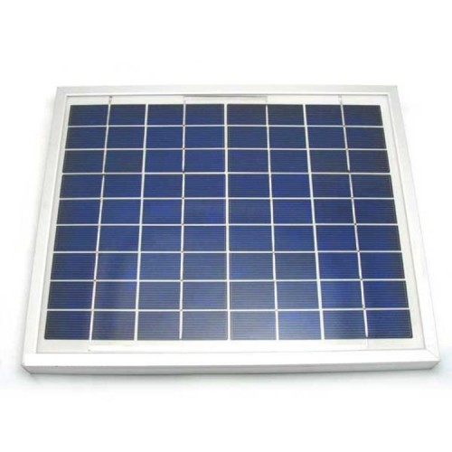

#### Fig 5.3.3 Solar Panel

#### **5.3.4 Solar Energy Used for Water Treatment**

Solar distillation can be used to make [saline](http://en.wikipedia.org/wiki/Saline_water) or [brackish water](http://en.wikipedia.org/wiki/Brackish_water) potable. The first recorded instance of this was by 16th-century Arab alchemists. A large-scale solar distillation project was first constructed in 1872 in the [Chilean](http://en.wikipedia.org/wiki/Chile) mining town of Las Salinas. The plant, which had solar collection area of 4,700 m2 (51,000 sq. ft.), could produce up to 22,700 L (5,000 imp gal; 6,000 US gal) per day and operate for 40 years. Individual [still](http://en.wikipedia.org/wiki/Still) designs include single-slope, double-slope (or greenhouse type), vertical, conical, inverted absorber, multi-wick, and multiple effect. These stills can operate in passive, active, or hybrid modes. Double-slope stills are the most economical for decentralized domestic purposes; while active multiple effect units are more suitable for large-scale applications.

Solar water [disinfection](http://en.wikipedia.org/wiki/Disinfection) (SODIS) involves exposing water-filled plastic [polyethylene terephthalate](http://en.wikipedia.org/wiki/Polyethylene_terephthalate) (PET) bottles to sunlight for several hours. Exposure times vary depending on weather and climate from a minimum of six hours to two days during fully overcast conditions. It is recommended by the [World Health Organization](http://en.wikipedia.org/wiki/World_Health_Organization) as a viable method for household water treatment and safe storage. Over two million people in developing countries use this method for their daily drinking water.

Solar energy may be used in a water stabilization pond to treat [waste water](http://en.wikipedia.org/wiki/Waste_water) without chemicals or electricity. A further environmental advantage is that [algae](http://en.wikipedia.org/wiki/Algae) grow in such ponds and consume [carbon dioxide](http://en.wikipedia.org/wiki/Carbon_dioxide) in photosynthesis, although algae may produce toxic chemicals that make the water unusab

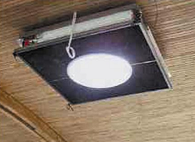

Fig 5.3.4 Solar Light

Solar light pipes, compared to conventional skylights and other [windows](http://en.wikipedia.org/wiki/Window), offer better heat insulation properties and more flexibility for use in inner rooms, but less visual contact with the external environment. Compared to [artificial lights](http://en.wikipedia.org/wiki/Lamp_(electrical_component)), light tubes have the advantage of providing natural light and of saving energy. The transmitted light varies over the day; should this not be desired, light tubes can be combined with artificial light in a [hybrid](http://en.wikipedia.org/wiki/Daylighting#Hybrid_solar_lighting) set-up.

On a more practical note, light tubes do not require electric installations or insulation, and are thus especially useful for indoor wet areas such as bathrooms and pools. From a more artistic point of view, recent developments, especially those pertaining to transparent light tubes, open new and interesting possibilities for architectural design

**5.4 Wind energy**

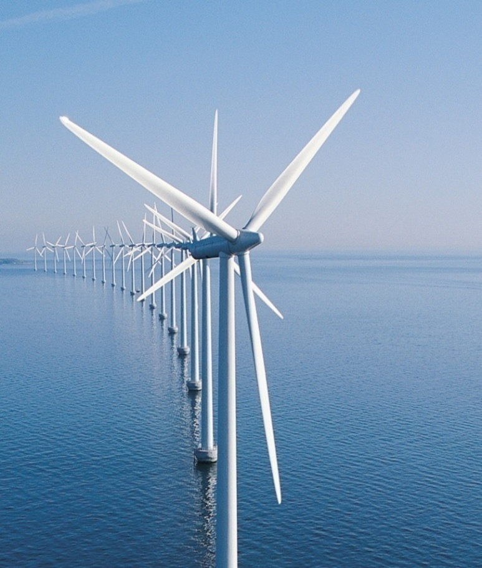

Fig 5.4 Windmill

Wind power is extracted from [air flow](http://en.wikipedia.org/wiki/Wind) using [wind turbines](http://en.wikipedia.org/wiki/Wind_turbine) or [sails](http://en.wikipedia.org/wiki/Sail) to produce mechanical or [electrical power](http://en.wikipedia.org/wiki/Electrical_power). [Windmills](http://en.wikipedia.org/wiki/Windmill) are used for their mechanical power, [wind pumps](http://en.wikipedia.org/wiki/Windpump) for [water pumping](http://en.wikipedia.org/wiki/Water_pumping), and [sails](http://en.wikipedia.org/wiki/Sail) to propel [ships](http://en.wikipedia.org/wiki/Sailing_ship). Wind energy as an alternative to [fossil fuels](http://en.wikipedia.org/wiki/Fossil_fuel), is plentiful, [renewable](http://en.wikipedia.org/wiki/Renewable_energy), widely distributed, [clean](http://en.wikipedia.org/wiki/Sustainable_energy), produces no [greenhouse gas](http://en.wikipedia.org/wiki/Greenhouse_gas) emissions during operation and uses little land. The [effects on the environment](http://en.wikipedia.org/wiki/Environmental_impact_of_wind_power) are generally less problematic than those from other power sources.

Large [wind farms](http://en.wikipedia.org/wiki/Wind_farm) consist of thousands of individual wind turbines which are connected to the [electric power transmission](http://en.wikipedia.org/wiki/Electric_power_transmission) network. According to the recent [EU](http://en.wikipedia.org/wiki/EU) analysis for new constructions, onshore wind is an inexpensive source of electricity, competitive with or in many places cheaper than coal, gas or fossil fuel plants. Offshore wind is steadier and stronger than on land, and offshore farms have less visual impact, but construction and maintenance costs are considerably higher. Small onshore wind farms can feed some energy into the grid or provide electricity to isolated off-grid locations.

Wind power is very consistent from year to year but has significant variation over shorter time scales. It is therefore used in conjunction with other sources to give a reliable supply. As the proportion of wind power in a region increases, a need to upgrade the grid and a lowered ability to supplant conventional production can occur. Power management techniques such as having excess capacity storage, geographically distributed turbines, dispatch able backing sources, storage such as pumped, exporting and importing power to neighboring areas or reducing demand when wind production is low, can greatly mitigate these problems. In addition, [weather forecasting](http://en.wikipedia.org/wiki/Weather_forecast) permits the electricity network to be readied for the predictable variations in production that occur.

As of 2013, [Denmark is generating](http://en.wikipedia.org/wiki/Wind_power_in_Denmark) more than a third of its electricity from wind and 83 countries around the world are using wind power to supply the electricity grid. Wind power capacity has expanded rapidly to 336 [GW](http://en.wikipedia.org/wiki/Gigawatt) in June 2014, and wind energy production was around 4% of total worldwide electricity usage, and growing rapidly.

**5.4.1 Wind Pattern for Home**

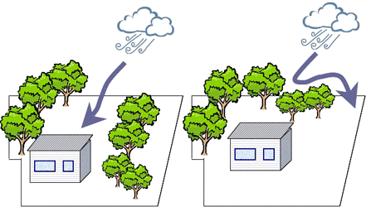

**Fig 5.4.1 Wind Pattern for House**

**5.4.2 Natural Ventilation**

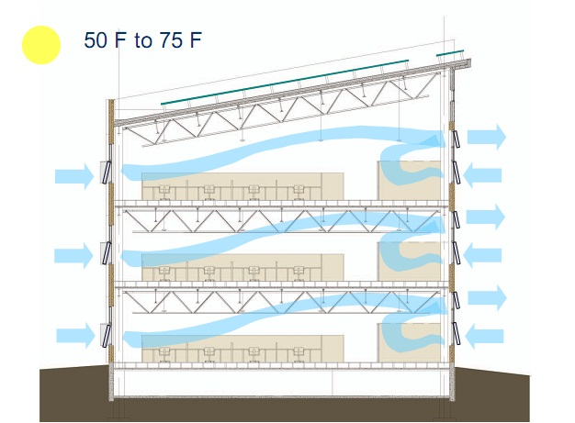

Fig 5.4.2 Natural Ventilation

Natural ventilation is the process of supplying air to and removing air from an indoor space without using mechanical systems. It refers to the flow of external air to an indoor space as a result of pressure differences arising from natural forces.

**5.5 Green Roof**

Here we have designing the building which will be smart Vegetated Roof Systems (aka: green roofs) are used extensively in Europe to manage storm water, reduce energy consumption, and for aesthetic appeal. They are gaining popularity in the United States especially in larger cities that are required to meet stringent requirements to manage storm water. Green roofs can be installed on new construction or retrofits to existing buildings as long as the facility has the necessary structural integrity (check with a structural engineer). There are variety systems available for commercial to residential applications. The two types of green roofs are: intensive and extensive. Intensive green roofs are typically more elaborate systems while extensive roofs can still be lush, but require less material.

**5.5.1 What is Green Roof?**

A green roof or living roof is a [roof](https://en.wikipedia.org/wiki/Roof) of a [building](https://en.wikipedia.org/wiki/Building) that is partially or completely covered with vegetation and a growing medium, planted over a [waterproofing membrane](https://en.wikipedia.org/wiki/Waterproofing#Construction_waterproofing). It may also include additional layers such as a [root barrier](https://en.wikipedia.org/wiki/Root_barrier) and [drainage](https://en.wikipedia.org/wiki/Drainage) and [irrigation](https://en.wikipedia.org/wiki/Irrigation) systems. [Container gardens](https://en.wikipedia.org/wiki/Container_garden) on roofs, where plants are maintained in pots, are not generally considered to be true green roofs, although this is debated. Rooftop ponds are another form of green roofs which are used to treat [grey water](https://en.wikipedia.org/wiki/Greywater).

Green roofs serve several purposes for a building, such as [absorbing](https://en.wikipedia.org/wiki/Absorption_of_water) [rainwater](https://en.wikipedia.org/wiki/Rainwater), providing [insulation](https://en.wikipedia.org/wiki/Building_insulation), creating a habitat for wildlife, increasing benevolence and decreasing stress of the people around the roof by providing a more aesthetically pleasing landscape, and helping to lower urban air temperatures and mitigate the [heat island effect](https://en.wikipedia.org/wiki/Heat_island_effect). They effectively utilize the natural functions of plants to filter water and treat air in urban and suburban landscapes. There are two types of green roof: intensive roofs, which are thicker, with a minimum depth of 12.8 cm (5.0 in), and can support a wider variety of plants but are heavier and require more maintenance, and extensive roofs, which are shallow, ranging in depth from 2 cm (0.79 in) to 12.7 cm (5.0 in), lighter than intensive green roofs, and require minimal maintenance.

The term green roof may also be used to indicate roofs that use some form of green technology, such as a [cool roof](https://en.wikipedia.org/wiki/Cool_roof), a roof with [solar thermal collectors](https://en.wikipedia.org/wiki/Solar_thermal_collector) or [photovoltaic panels](https://en.wikipedia.org/wiki/Photovoltaic_panels). Green roofs are also referred to as eco-roofs, oiko stages, vegetated roofs, living roofs, green roofs and VCPH (Horizontal Vegetated Complex Partitions)

**5.5.2 Benefits of Green Roof**

1. Insulation properties reduce energy use and costs by keeping buildings
2. cool in the summer and warm in the winter
3. Absorbs rainwater which displaces great volumes from sewage and
4. Storm water systems
5. Green roofs last much longer than a conventional roofs because the
6. underlying roof material is protected from UV exposure
7. Aesthetically pleasing, increasing urban quality of life; can provide usable
8. green space for a vegetable or herb garden, meditation garden, or
9. horticultural therapy
10. Decreases urban heat island effect by absorbing heat (a traditional rooftop
11. can be up to 90o warmer) (U.S. EPA)
12. Provides potential for wildlife habitat
13. Processes air pollution and collects airborne particles
14. Improves water quality (once the system stabilizes) by breaking down
15. pollutants through chemical, microbial, and physical means

A green roof, or rooftop garden, is a vegetative layer grown on a rooftop. Green roofs have a layer of living plant on top of the structure and the waterproofing elements. Green roofs can be installed on a wide range of buildings, from industrial facilities to private residences. They can be as simple as a 2-inch covering of hardy groundcover or as complex as a fully accessible park complete with trees and gardens.



Fig 5.5.2 Layers of Green Roof

**5.5.3 Components of green roof**

Each green roof system varies according to type and manufacturer, but essentially has the following components (see figure below):

1. Vegetation (see plant selection)
2. Growing Medium: mostly inorganic, lightweight mix
3. Root Barrier Filter Fabric: chemically treated fabric layer to discourage root penetration into lower layers
4. Drainage Membrane: allows drainage, stores water for plant uptake, provides aeration
5. Membrane protection and Moisture Barrier: fabric separating drainage membrane from insulation and water proofs the underlying roof material Insulation
6. Roofing Membrane: typical single-ply roofing membrane
7. Structural Support: building structure

**5.6 Green Wall**

"Vertical garden" redirects here. It is not to be confused with [Vertical farming](https://en.wikipedia.org/wiki/Vertical_farming).

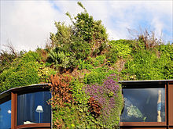

Detail of Patrick Blanc's exterior green wall of the Musée du Quai Branly (image 2012).

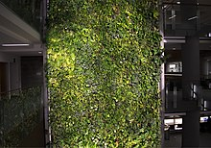

Fig 5.6.1 Green Wall

An indoor green wall at the [University of Ottawa](https://en.wikipedia.org/wiki/University_of_Ottawa).

A green wall is a wall partially or completely covered with greenery that includes a growing medium, such as soil or a substrate. Most green walls also feature an integrated water delivery system. A green wall is also known as a living wallor verticalgarden. It provides insulation to keep the building's inside temperature consistent.

It is useful to distinguish green walls from green facades. Green walls have growing media supported on the face of the wall (as described below), while green facades have soil only at the base of the wall (in a container or in ground) and support climbing plants on the face of the wall to create the green, or vegetated, facade.

Green walls may be indoors or outside, freestanding or attached to an existing wall, and come in a great variety of sizes.

[Stanley Hart White](https://en.wikipedia.org/wiki/Stanley_Hart_White), a Professor of Landscape Architecture at the [University of Illinois](https://en.wikipedia.org/wiki/University_of_Illinois) patented a "vegetation-Bearing Architectonic Structure and System" in 1938, though his invention did not progress beyond prototypes in his backyard in Urbana, Illinois.

Green walls subsequently saw a rapid surge in popularity. Of the 61 large-scale outdoor green walls listed in an online database provided by greenroof.com, 80% were constructed in or after 2009 and 93% in or after 2007. Many iconic green walls have been constructed by institutions and in public places such as airports and are now becoming common. As of 2015, the largest green wall covers 2,700 square meters (29,063 square feet or more than half an acre) and is located at the Los Cabos International Convention Center, a building designed by Mexican architect [Fernando Romero](https://en.wikipedia.org/wiki/Fernando_Romero)for the [2012 G-20 Los Cabos summit](https://en.wikipedia.org/wiki/2012_G-20_Los_Cabos_summit)

**5.6.1 Advantages**

Reduce roof storm water: in some cases this can help reduce the size of storm water pipes, and the amount of storm water that needs to be treated by municipal water treatment. In addition, green roofs filter pollutants from rainfall. A North Carolina study looked at the performance of a green roof and found that it reduced runoff during peak rainfall events by more than 75 percent.

1. Increased roof longevity: Protects the roof membrane from harmful ultraviolet radiation and acid rain, which slowly corrodes the roofing material. Only a couple inches of soil can greatly extend the life of the roof, reducing the necessity to constantly replace the less sustainable conventional roof. A green roof lasts on average 2-3 times that of its conventional counterpart and is estimated to sustain itself for up to 40 years.
2. Reduced energy use: Green roofs absorb heat by acting as natural insulators for buildings, reducing the consumption of energy for heating and cooling. A 32,000- square foot green roof implemented in Canada saved 6 percent on total cooling and 10 percent on total heating costs each year.
3. Green roofs remove particulate matter (PM) and other gaseous pollutants from the air, providing cleaner air, a source of oxygen, and a habitat for birds and insects. A study in Washington, D.C assumed 20 % of all roofs greater than 10,000 square feet were greened. The results showed that 6.0 tons of O3(ozone) and 6 tons of PM would be removed per year, equivalent to the quantity absorbed by 25,000 to 33,000 trees.
4. The aesthetic value of green roofs provides health benefits. When physically seeing or interacting with an aesthetically pleasing space, people are relieved of stress and can enter a more joyful and relaxed mental state*.* A study in Texas, involving post-surgery patients showed that recovery was faster and had less chance of relapse if patients could look out onto green space.

**5.6.2 Disadvantages**

* 1. Requires high skilled labour
  2. High maintenance cost
  3. Initial high cost

**5.6.3 Application**

Modeling results for green roof applications have shown similar, though varied, cooling energy savings, generally indicating overall annual (as opposed to monthly) building cooling load reductions of up to 25 percent, depending on building and green roof characteristics and the site’s climate.81 For example, in modeling analyses of extensive green roofs, researchers have estimated energy savings of: 17 percent of the cooling load for a hypothetical five-story commercial building in Singapore with a turf roof, and a 47 percent reduction for a rooftop covered by shrubs;82 more than 10 percent for a one-story commercial building in Santa Barbara, California; 83 and 12 percent for a one-story building in Portland, Oregon, with an average energy savings of 0.17 kWh/ft2 (equivalent to about 35 percent of the electricity use of an average California residence with central air-conditioning).84 Further, the tempered microclimate on a green roof can provide additional energy savings for buildings with rooftop air-conditioning or HVAC systems. In general, air-conditioning systems begin to decrease in operational efficiency at about 95°F.86 Green roofs tend to maintain a localized air temperature below that of ambient air, allowing cooler air to enter the air-conditioning system and reducing costs and energy used for cooling.

**5.7 Sewage Treatment Plant**

Sewage treatment is the process of removing [contaminants](https://en.wikipedia.org/wiki/Pollutant) from [wastewater](https://en.wikipedia.org/wiki/Wastewater), primarily from household sewage. Physical, chemical, and biological processes are used to remove contaminants and produce treated wastewater (or treated [effluent](https://en.wikipedia.org/wiki/Effluent)) that is safer for the environment. A by-product of sewage treatment is usually a semi-solid waste or slurry, called [sewage sludge](https://en.wikipedia.org/wiki/Sewage_sludge). The sludge has to undergo further [treatment](https://en.wikipedia.org/wiki/Sewage_sludge_treatment) before being suitable for disposal or application to land.

Sewage treatment may also be referred to as [wastewater treatment](https://en.wikipedia.org/wiki/Wastewater_treatment). However, the latter is a broader term which can also refer to industrial wastewater. For most cities, the [sewer system](https://en.wikipedia.org/wiki/Sanitary_sewer) will also carry a proportion of [industrial effluent](https://en.wikipedia.org/wiki/Industrial_wastewater_treatment) to the sewage treatment plant which has usually received pre-treatment at the factories themselves to reduce the pollutant load. If the sewer system is a [combined sewer](https://en.wikipedia.org/wiki/Combined_sewer) then it will also carry [urban runoff](https://en.wikipedia.org/wiki/Urban_runoff) (stormwater) to the sewage treatment plant. Sewage water can travel towards treatment plants via [piping](https://en.wikipedia.org/wiki/Piping) and in a flow aided by [gravity](https://en.wikipedia.org/wiki/Gravity) and [pumps](https://en.wikipedia.org/wiki/Pump). The first part of filtration of sewage typically includes a [bar screen](https://en.wikipedia.org/wiki/Bar_screen) to filter solids and large objects which are then collected in [dumpsters](https://en.wikipedia.org/wiki/Dumpster) and disposed of in landfills. [Fat](https://en.wikipedia.org/wiki/Fat) and [grease](https://en.wikipedia.org/wiki/Grease_%28lubricant%29) is also removed before the primary treatment of sewage.

Sewage is generated by residential, institutional, commercial and industrial establishments. It includes [household waste](https://en.wikipedia.org/wiki/Household_waste) liquid from [toilets](https://en.wikipedia.org/wiki/Toilet), [baths](https://en.wikipedia.org/wiki/Bathing), [showers](https://en.wikipedia.org/wiki/Shower), [kitchens](https://en.wikipedia.org/wiki/Kitchen), and [sinks](https://en.wikipedia.org/wiki/Sink) draining into [sewers](https://en.wikipedia.org/wiki/Sanitary_sewer). In many areas, sewage also includes liquid waste from industry and commerce. The separation and draining of household waste into [greywater](https://en.wikipedia.org/wiki/Greywater) and [blackwater](https://en.wikipedia.org/wiki/Blackwater_%28waste%29) is becoming more common in the developed world, with treated greywater being permitted to be used for watering plants or recycled for flushing toilets.

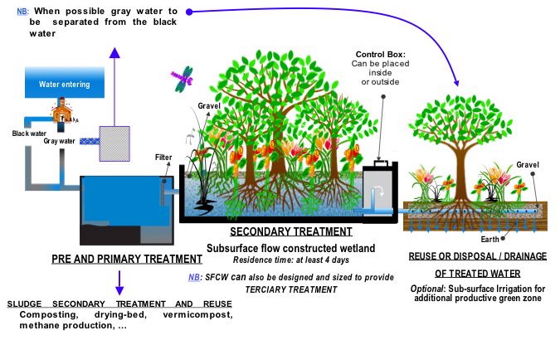

Fig 5.7 Sewage Treatment Process

**5.7.1 Energy requirements**

## For conventional sewage treatment plants, around 30 percent of the annual operating costs is usually required for energy. The energy requirements vary with type of treatment process as well as wastewater load. For example, [constructed wetlands](https://en.wikipedia.org/wiki/Constructed_wetland) have a lower energy requirement than [activated sludge](https://en.wikipedia.org/wiki/Activated_sludge) plants, as less energy is required for the aeration step. Sewage treatment plants that produce biogas in their [sewage sludge treatment](https://en.wikipedia.org/wiki/Sewage_sludge_treatment) process with [anaerobic digestion](https://en.wikipedia.org/wiki/Anaerobic_digestion) can produce enough energy to meet most of the energy needs of the sewage treatment plant itself.

In conventional secondary treatment processes, most of the electricity is used for aeration, pumping systems and equipment for the dewatering and drying of [sewage sludge](https://en.wikipedia.org/wiki/Sewage_sludge). Advanced wastewater treatment plants, e.g. for nutrient removal, require more energy than plants that only achieve primary or secondary treatment.

**5.8 Water Treatment Plant**

Water treatment is the process that improves the quality of water to make it more acceptable for a specific end-use. The end use may be drinking, industrial water supply, irrigation, river flow maintenance, water recreation or many other uses, including being safely returned to the environment. Water treatment removes contaminants and undesirable components, or reduces their concentration so that the water becomes fit for its desired end-use.Water supplied to domestic properties may be further treated before use, often using an in-line treatment process. Such treatments can include water softening or ion exchange. Many proprietary systems also claim to remove residual disinfectants and heavy metal ions.Water flows through a filter designed to remove particles in the water. The filters are made of layers of sand and gravel, and in some cases, crushed anthracite. Filtration collects the suspended impurities in water and enhances the effectiveness of disinfection. The filters are routinely cleaned by backwashing.The next step is generally running the water overflow into gravity sand filters. These filters are big areas where they put two to four feet of sand, which is a finely crushed silica sand with jagged edges.

The sand is typically installed in the filter at a depth of two to four feet, where it packs tightly. The feed water is then passed through, **trapping the particles.** On smaller industrial systems, you might go with a packed-bed pressure multimedia filter versus gravity sand filtration. Sometimes, depending on the water source and whether or not it has a lot of iron, you can also use a green sand filter instead of the sand filter, but for most part, the polishing step for conventional raw water treatment is sand filtration.Ultra filtration (UF) can also be used after the clarifiers instead of the gravity sand filter, or it can replace entire clarification process altogether. Membranes have become the newest technology for treatment, pumping water directly from the raw water source through the UF (post-chlorination) and **eliminating the entire clarifier/filtration train.**

**5.8.1 ENERGY CONSUMPTION**

Many cities, drinking water and wastewater treatment plants are typically the largest energy consumers, having a total of 30-40% of the cities' energy consumption. More than 4% of the nation's electricity goes towards moving and treating water and wastewater. Cost of these energy is consumed in the flocculation basin for drinking water treatment plants and in the aeration basin for wastewater treatment plants. High amount of energy is needed to mix the large volume of water to allow sedimentations to flocculate together. There are current technologies that may aim to reduce this amount of energy. These include optimizing system processes by modifying and improving pumping and aeration equipments. The effectiveness of such technologies are still under discussion as they take up a lot of energy.

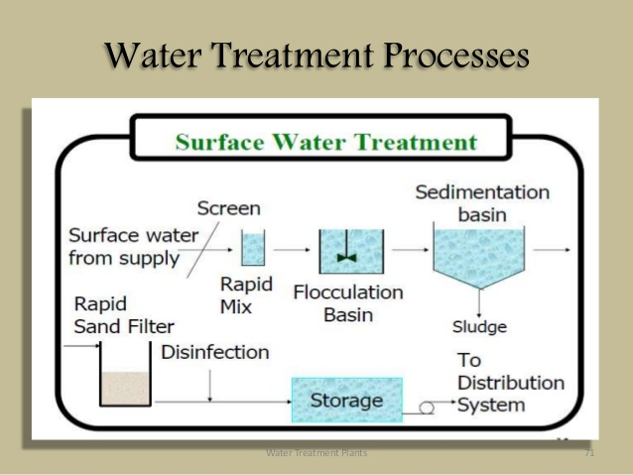

Fig 5.8.1 Water Treatment Process

**5.9 Biogas plant**

Biomass resources such as cattle dung, agriculture wastes and other organic wastes have been one of the main energy sources for the mankind since the dawn of civilization. There is a vast scope to convert these energy sources into biogas. Biogas production is a clean low carbon technology for efficient management and conversion of fermentable organic wastes into clean cheap & versatile fuel and bio/organic manure. It has the potential for leveraging sustainable livelihood development as well as tackling local and global land, air and water pollution. Biogas obtained by anaerobic digestion of cattle dung and other loose & leafy organic matters/ biomass wastes can be used as an energy source for various applications namely, cooking, heating, space cooling/ refrigeration, electricity generation and gaseous fuel for vehicular application. Based on the availability of cattle dung alone from about 304 million cattle, there exists an estimated potential of about 18,240 million cubic meter of biogas generation annually.

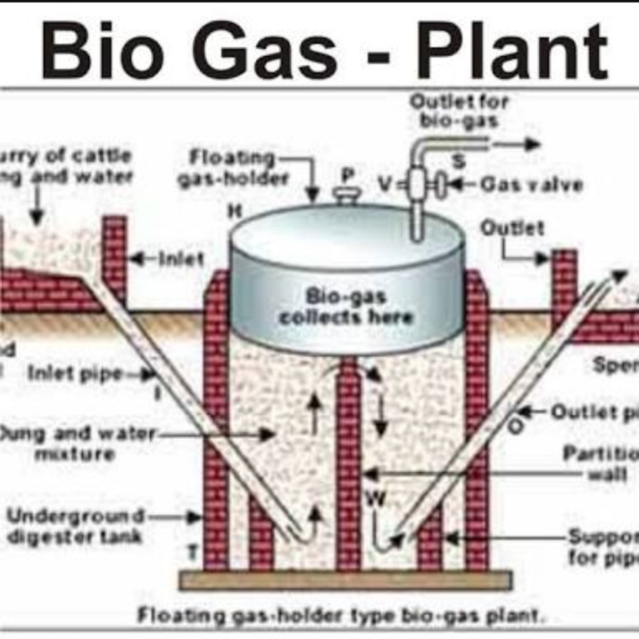

Fig 5.9 Biogas Plant

India is implementing one of the World’s largest programmed in renewable energy. The country ranks second in biogas utilization. Biogas can be generated and supplied round the clock in contrast to solar and wind, which are intermittent in nature. Biogas plants provide three-in-one solution of gaseous fuel generation, organic manure production and wet biomass waste disposal/management.

Biogas is a product of bio-machination process when fermentable organic materials such as cattle dung, kitchens waste, poultry droppings, night soil wastes, agricultural wastes etc. are subjected to anaerobic digestion in the presence of methanogen bacteria. This process is better as the digested slurry from biogas plants is available for its utilization as bio/organic manure in agriculture, horticulture and pisciculture as a substitute/supplement to chemical fertilizers. In contrast, when biomass is subjected to combustion/gasification process, it ends up in the destruction of biomass and only ash is left after extraction of energy. Therefore, the bio-machination process of converting biomass into gaseous fuel is superior and a sustainable process that needs to be preferred for such biomass materials that can be processed in biogas plants

**5.7.1 Advantages**

1. Methane is a very powerful greenhouse gas: its global warming potential it 23 times higher than that of C02. In this way, recovering of biogas is very interesting to limit the greenhouse effect.

2. Biogas is a renewable energy form because biomass naturally releases biogas by decomposing. By using biogas as an energy source, we can reduce our dependency on fossil resources as coal, oil and natural gas.

3. Low cost

4. Ease of transportation

5. Low construction

**5.7.2 Disadvantages**

1. Few Technological Advancements

2. Contains Impurities

3. Effect of Temperature on Biogas Production

4. Less Suitable For Dense Metropolitan Areas

**5.7.3 Application**

1. Cooking

2. Heating,

3. Space cooling/ refrigeration

4. Electricity generation

**CHAPTER VI**

**ABSTRACT SHEET**

|  |  |  |  |  |  |
| --- | --- | --- | --- | --- | --- |
| **Earth Work** | | | | | |
| **Earth Work in Excavation in Foundation and Filling under Floors** | | | | |  |
| Area ( in sq.ft ) |  | Description |  | |  |
| **Item** | **Quantity** | **Units** | **Price Per Unit** | **Total Amount** |  |
| Labour for Earth Excavation & Earth Filling |  |  |  |  |  |
|  |  |  |  |  |  |
|  | | | Sub Total           Rs. |  |  |
|  | | | | | | | | | | | | | | | | | | | | | | | | | | | | | | | | | | | | | | | | | | | | | | | | | |
| **Cement Concrete** | | | |  |  |  |  |  |  |  |  |  |  |  |  |  |  |  |  |  |  |  |  |  |  |  |  |  |  |  |  |  |  |  |  |  |  |  |  |  |  |  |  |  |  |  |  |  |  |
| **Foundation Concrete 1:8:16** | | | | |  |  |  |  |  |  |  |  |  |  |  |  |  |  |  |  |  |  |  |  |  |  |  |  |  |  |  |  |  |  |  |  |  |  |  |  |  |  |  |  |  |  |  |  |  |
| Area ( in sq.ft ) |  | Description |  | |  |  |  |  |  |  |  |  |  |  |  |  |  |  |  |  |  |  |  |  |  |  |  |  |  |  |  |  |  |  |  |  |  |  |  |  |  |  |  |  |  |  |  |  |  |
| **Item** | **Quantity** | **Units** | **Price Per Unit** | **Total Amount** |  |  |  |  |  |  |  |  |  |  |  |  |  |  |  |  |  |  |  |  |  |  |  |  |  |  |  |  |  |  |  |  |  |  |  |  |  |  |  |  |  |  |  |  |  |
| Cement |  | Bags |  |  |  |  |  |  |  |  |  |  |  |  |  |  |  |  |  |  |  |  |  |  |  |  |  |  |  |  |  |  |  |  |  |  |  |  |  |  |  |  |  |  |  |  |  |  |  |
| Sand |  | CUM |  |  |  |  |  |  |  |  |  |  |  |  |  |  |  |  |  |  |  |  |  |  |  |  |  |  |  |  |  |  |  |  |  |  |  |  |  |  |  |  |  |  |  |  |  |  |  |
| Brick Blast |  | CUM |  |  |  |  |  |  |  |  |  |  |  |  |  |  |  |  |  |  |  |  |  |  |  |  |  |  |  |  |  |  |  |  |  |  |  |  |  |  |  |  |  |  |  |  |  |  |  |
| Labour for Cement Concrete |  |  |  |  |  |  |  |  |  |  |  |  |  |  |  |  |  |  |  |  |  |  |  |  |  |  |  |  |  |  |  |  |  |  |  |  |  |  |  |  |  |  |  |  |  |  |  |  |  |
|  | | | Sub Total           Rs. |  |  |  |  |  |  |  |  |  |  |  |  |  |  |  |  |  |  |  |  |  |  |  |  |  |  |  |  |  |  |  |  |  |  |  |  |  |  |  |  |  |  |  |  |  |  |
| **Cement Concrete 1:6:12** | | | | |  |  |  |  |  |  |  |  |  |  |  |  |  |  |  |  |  |  |  |  |  |  |  |  |  |  |  |  |  |  |  |  |  |  |  |  |  |  |  |  |  |  |  |  |  |
| Area ( in sq.ft ) |  | Description |  | |  |  |  |  |  |  |  |  |  |  |  |  |  |  |  |  |  |  |  |  |  |  |  |  |  |  |  |  |  |  |  |  |  |  |  |  |  |  |  |  |  |  |  |  |  |
| **Cement Concrete 1:4:8** | | | | |  |  |  |  |  |  |  |  |  |  |  |  |  |  |  |  |  |  |  |  |  |  |  |  |  |  |  |  |  |  |  |  |  |  |  |  |  |  |  |  |  |  |  |  |  |
| Area ( in sq.ft ) |  | Description |  | |  |  |  |  |  |  |  |  |  |  |  |  |  |  |  |  |  |  |  |  |  |  |  |  |  |  |  |  |  |  |  |  |  |  |  |  |  |  |  |  |  |  |  |  |  |

**ABSTRACT SHEET**

|  |  |  |  |  |  |  |  |  |  |  |  |  |  |  |  |  |  |  |  |  |  |  |  |  |  |  |  |  |  |  |  |  |  |  |  |  |  |  |  |  |  |  |  |  |  |  |  |  |  |
| --- | --- | --- | --- | --- | --- | --- | --- | --- | --- | --- | --- | --- | --- | --- | --- | --- | --- | --- | --- | --- | --- | --- | --- | --- | --- | --- | --- | --- | --- | --- | --- | --- | --- | --- | --- | --- | --- | --- | --- | --- | --- | --- | --- | --- | --- | --- | --- | --- | --- |
|  | | | | | | | | | | | | | | | | | | | | | | | | | | | | | | | | | | | | | | | | | | | | | | | | | |
| **Brick Work in Foundation** | | | |  |  |  |  |  |  |  |  |  |  |  |  |  |  |  |  |  |  |  |  |  |  |  |  |  |  |  |  |  |  |  |  |  |  |  |  |  |  |  |  |  | | |  | | | |  |  |  |  |
| **Brick Work in Foundation with Cement Mortar 1:7** | | | | |  |  |  |  |  |  |  |  |  |  |  |  |  |  |  |  |  |  |  |  |  |  |  |  |  |  |  |  |  |  |  |  |  |  |  |  |  |  |  |  |  | | |  | | | |  |  |  |
| Area ( in sq.ft ) |  | Description |  | |  |  |  |  |  |  |  |  |  |  |  |  |  |  |  |  |  |  |  |  |  |  |  |  |  |  |  |  |  |  |  |  |  |  |  |  |  |  | | |  | | |  | |  |  |  |  |  |
| **Item** | **Quantity** | **Units** | **Price Per Unit** | **Total Amount** |  |  |  |  |  |  |  |  |  |  |  |  |  |  |  |  |  |  |  |  |  |  |  |  |  |  |  |  |  |  |  |  |  |  |  |  |  | | |  | | |  |  | |  |  |  |  |  |
| Cement |  | Bags |  |  |  |  |  |  |  |  |  |  |  |  |  |  |  |  |  |  |  |  |  |  |  |  |  |  |  |  |  |  |  |  |  |  |  |  |  |  |  | | |  | | |  |  | |  |  |  |  |  |
| Sand |  | CUM |  |  |  |  |  |  |  |  |  |  |  |  |  |  |  |  |  |  |  |  |  |  |  |  |  |  |  |  |  |  |  |  |  |  |  |  |  |  |  | | |  | | |  |  | |  |  |  |  |  |
| Bricks |  | NOS |  |  |  |  |  |  |  |  |  |  |  |  |  |  |  |  |  |  |  |  |  |  |  |  |  |  |  |  |  |  |  |  |  |  |  |  |  |  |  | | |  | | |  |  | |  |  |  |  |  |
| Labour for Brick Work Foundation |  |  |  |  |  |  |  |  |  |  |  |  |  |  |  |  |  |  |  |  |  |  |  |  |  |  |  |  |  |  |  |  |  |  |  |  |  |  |  |  |  | | |  | | |  |  | |  |  |  |  |  |
|  | | | Sub Total           Rs. |  |  |  |  |  |  |  |  |  |  |  |  |  |  |  |  |  |  |  |  |  |  |  |  |  |  |  |  |  |  |  |  |  |  |  |  |  |  |  |  | | |  | | | |  |  |  |  |  |
| **Brick Work in Foundation with Cement Mortar 1:6** | | | | |  |  |  |  |  |  |  |  |  |  |  |  |  |  |  |  |  |  |  |  |  |  |  |  |  |  |  |  |  |  |  |  |  |  |  |  |  |  |  |  |  | | |  | | | |  |  |  |
| Area ( in sq.ft ) |  | Description |  | |  |  |  |  |  |  |  |  |  |  |  |  |  |  |  |  |  |  |  |  |  |  |  |  |  |  |  |  |  |  |  |  |  |  |  |  |  |  | | |  | | |  | |  |  |  |  |  |
| **Brick Work in Foundation with Cement Mortar 1:4** | | | | |  |  |  |  |  |  |  |  |  |  |  |  |  |  |  |  |  |  |  |  |  |  |  |  |  |  |  |  |  |  |  |  |  |  |  |  |  |  |  |  |  | | |  | | | |  |  |  |
| Area ( in sq.ft ) |  | Description |  | |  |  |  |  |  |  |  |  |  |  |  |  |  |  |  |  |  |  |  |  |  |  |  |  |  |  |  |  |  |  |  |  |  |  |  |  |  |  | | |  | | |  | |  |  |  |  |  |
|  |  |  |  |  |  |  |  |  |  |  |  |  |  |  |  |  |  |  |  |  |  |  |  |  |  |  |  |  |  |  |  |  |  |  |  |  |  |  |  |  |  | | |  | | |  |  | |  |  |  |  |  |
|  |  |  |  |  |  |  |  |  |  |  |  |  |  |  |  |  |  |  |  |  |  |  |  |  |  |  |  |  |  |  |  |  |  |  |  |  |  |  |  |  |  | | |  | | |  |  | |  |  |  |  |  |
|  |  |  |  |  |  |  |  |  |  |  |  |  |  |  |  |  |  |  |  |  |  |  |  |  |  |  |  |  |  |  |  |  |  |  |  |  |  |  |  |  |  | | |  | | |  |  | |  |  |  |  |  |
|  | | | | | | | | | | | | | | | | | | | | | | | | | | | | | | | | | | | | | | | | | | | | | | | | | |
| **DPC** | | | | | |  |  |  |  |  |  |  |  |  |  |  |  |  |  |  |  |  |  |  |  |  |  |  |  |  |  |  |  |  |  |  |  |  |  |  |  |  |  |  |  |  |  |  |  |
| **Horizontal DPC with Cement Concrete 1:2:4( 40MM)** | | | | |  |  |  |  |  |  |  |  |  |  |  |  |  |  |  |  |  |  |  |  |  |  |  |  |  |  |  |  |  |  |  |  |  |  |  |  |  |  |  |  |  |  |  |  |  |
| Area ( in sq.ft ) |  | Description |  | |  |  |  |  |  |  |  |  |  |  |  |  |  |  |  |  |  |  |  |  |  |  |  |  |  |  |  |  |  |  |  |  |  |  |  |  |  |  |  |  |  |  |  |  |  |
| **Item** | **Quantity** | **Units** | **Price Per Unit** | **Total Amount** |  |  |  |  |  |  |  |  |  |  |  |  |  |  |  |  |  |  |  |  |  |  |  |  |  |  |  |  |  |  |  |  |  |  |  |  |  |  |  |  |  |  |  |  |  |
| Cement |  | Bags |  |  |  |  |  |  |  |  |  |  |  |  |  |  |  |  |  |  |  |  |  |  |  |  |  |  |  |  |  |  |  |  |  |  |  |  |  |  |  |  |  |  |  |  |  |  |  |
| Coarse Sand |  | CUM |  |  |  |  |  |  |  |  |  |  |  |  |  |  |  |  |  |  |  |  |  |  |  |  |  |  |  |  |  |  |  |  |  |  |  |  |  |  |  |  |  |  |  |  |  |  |  |
| Bazri |  | CUM |  |  |  |  |  |  |  |  |  |  |  |  |  |  |  |  |  |  |  |  |  |  |  |  |  |  |  |  |  |  |  |  |  |  |  |  |  |  |  |  |  |  |  |  |  |  |  |
| Bitumen |  | Kg |  |  |  |  |  |  |  |  |  |  |  |  |  |  |  |  |  |  |  |  |  |  |  |  |  |  |  |  |  |  |  |  |  |  |  |  |  |  |  |  |  |  |  |  |  |  |  |
| Labour for DPC |  |  |  |  |  |  |  |  |  |  |  |  |  |  |  |  |  |  |  |  |  |  |  |  |  |  |  |  |  |  |  |  |  |  |  |  |  |  |  |  |  |  |  |  |  |  |  |  |  |
|  |  |  |  |  |  |  |  |  |  |  |  |  |  |  |  |  |  |  |  |  |  |  |  |  |  |  |  |  |  |  |  |  |  |  |  |  |  |  |  |  |  |  |  |  |  |  |  |  |  |
|  | | | Sub Total           Rs. |  |  |  |  |  |  |  |  |  |  |  |  |  |  |  |  |  |  |  |  |  |  |  |  |  |  |  |  |  |  |  |  |  |  |  |  |  |  |  |  |  |  |  |  |  |  |
|  | | | | | | | | | | | | | | | | | | | | | | | | | | | | | | | | | | | | | | | | | | | | | | | | | |
| **Total cost of Foundation       Rs.** | | | |  |  |  |  |  |  |  |  |  |  |  |  |  |  |  |  |  |  |  |  |  |  |  |  |  |  |  |  |  |  |  |  |  |  |  |  |  |  |  |  |  |  |  |  |  |  |

Table No. 6.1 Abstract Sheet

**CHAPTER VII**

**SMART BUILDING**

**SMART BUILDING**

# 7.1 What is a Smart Building?

The first buildings ever constructed were primitive shelters made from stones, sticks, animal skins and other natural materials. While they hardly resembled the steel and glass that make up a modern city skyline, these early structures had the same purpose - to provide a comfortable space for the people inside. Buildings today are complex concatenations of structures, systems and technology. Over time, each of the components inside a building has been developed and improved, allowing modern-day building owners to select lighting, security, heating, and ventilation and air conditioning systems independently, as if they were putting together a home entertainment system.

But building owners today are beginning to look outside the four walls and consider the impact of their building on the electrical grid, the mission of their organization, and the global environment. To meet these objectives, it is not enough for a building to simply containthe systems that provide comfort, light and safety. Buildings of the future must connectthe various pieces in an integrated, dynamic and functional way. This vision is a building that seamlessly fulfills its mission while minimizing energy cost, supporting a robust electric grid and mitigating environmental impact.

At the most fundamental level, smart buildings deliver useful building services that make occupants productive (e.g. Illumination, thermal comfort, air quality, physical security, sanitation, and many more) at the lowest cost and environmental impact over the building lifecycle. Reaching this vision requires adding intelligence from the beginning of design phase through to the end of the building's useful life. Smart buildings use information technology during operation to connect a variety of subsystems, which typically operate independently, so that these systems can share information to optimize total building performance. Smart buildings look beyond the building equipment within their four walls. They are connected and responsive to the smart power grid, and they interact with building operators and occupants to empower them with new levels of visibility and actionable information.

Enabled by technology, this smart building connects the structure itself to the functions it exists to fulfill:

* Connecting building systems
* Connecting people and technology
* Connecting to the bottom line
* Connecting to the global environment
* Connecting to the smart power grid
* Connecting to an intelligent future

## 7.2 Connecting People and Technology

The most sophisticated software and elaborate hardware in the world would be nothing but wires and transistors without the people that use them to work more effectively. In that sense, the people that run a smart building are a crucial component of its intelligence.

With budgets tight and staff constrained, there is no room for difficult training and steep learning curves in modern day facility management. Instead, a truly smart building provides intuitive tools that are designed to improve and enhance the existing efforts of the people on the ground. As the smart building evolves, the sharing of information between smart building systems and components will provide the platform for innovation. Future applications will appear as facility managers interact with tools and technology to do their jobs better – providing more comfort, more safety, and more security with less money, less energy, and less environmental impact.

**7.3** **Reasons for Concern**

1. Standards of energy efficiency in almost all part of the world are extremely low.
2. Most of the countries are heavily dependent on imported oil, a finite resource that is likely to be increasingly expensive in future; consumption also has significant environmental costs.
3. Many of the developing countries have serious balance of payments problem.

**7.4 What is a Smart Energy Building?**

1. A smart energy building can be defined as a building which generates as much energy through renewable sources as much as it consumes from the Grid.
2. During the last 20 years more than 200 reputable projects claiming smart energy balance have been realized all over the world which extensively utilise the non-renewable energy sources to earn the tag of SMART BUILDING.

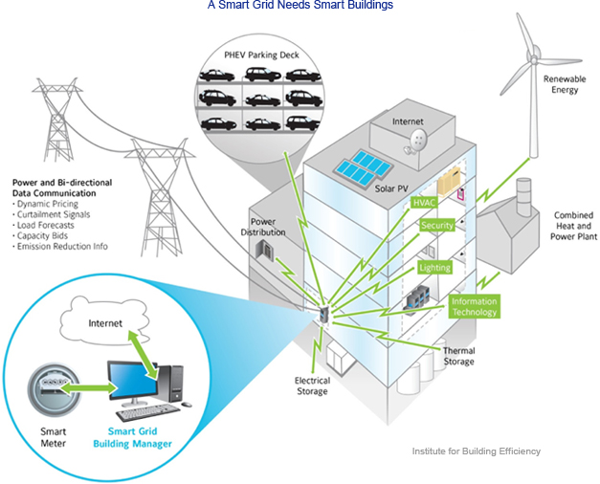

Fig 7.4 Smart Energy Building

A building doesn’t have to be new to be efficient. Today’s leading building owners are retrofitting buildings, converting existing buildings into models of sustainability.  While most building owners still pursue single technology improvements, market leaders bundle together energy saving technologies to get deeper savings in a more comprehensive approach. Energy performance contracting is one business model that enables building owners to implement whole building retrofits and significantly lower energy consumption and operating costs. Essentially, the upgrades are paid for through energy savings over time

Here we have designed the system which will control solar light using ldr which will turn on light only at night time system will only work on solar also system consist of solar and wind energy which will work whole smart city for free also system include solar tree so the space required for the solar panel will be reduced system will also use the bio gas plant to generate energy

**CHAPTER VIII**

**SMART BUILDING**

**COSTING OF SMART BUILDING**

**8.1 Costing of Building Equipments**

**Earth Work**

**Earth Work in Excavation in Foundation and Filling under Floors**

**Glass = 500 sqfeet x 1000 = 5,00,000**

**Flap Windows per unit 3000/-**

**Lowered Windows per unit 1500/-**

**Sintex PVC doubleDoor 4 x 10,000 = 40,000**

**Sintex PVC single Door 4 x 5000 = 20,000**

**Indoor Paint 20 x 20 feet Room (4 wall )=5000 x 4=20,000**

**With plasticPaint(25 % material +75% Labour )**

**Outdoor**

**200 Rs per squre feet 1000 x 200 =2,00,000/-**

**Floor Cost :- 500 sq feet sparked tile**

**Street light 10,000 per unit**

**Solar panel & battery for 1 unit 18,000/-**

**8.2 Costing of material**

1. Gree Roof layer cost 100/- per square feet
2. Geotextilelayer cost 100/- per square feet
3. Waterproofinglayer cost 100/- per square feet
4. Geotextilelayer cost 100/- per square feet
5. Stone woollayer cost 100/- per square feet
6. Irrigation systemlayer cost 100/- per square feet
7. Plantslayer cost 100/- per square feet
8. Soil substratelayer cost 100/- per square feet

**CHAPTER IX**

**FIRE DETECTION BY GSMFire Detection by GSM**

In this method we are building a **Fire Alarm System** using Arduino, LM35 Temperature Sensor and GSM Module. The objectives of this **fire detector** using arduino is to sense the surroundings for occurrence of fire with help of LM35 temperature sensor, and send 3 SMS alerts to two mobile numbers stored inside the arduino program if fire is detected (using GSM Module).

A **GSM MODULE** is basically a GSM Modem (like SIM 900) connected to a PCB with different types of output taken from the board – say TTL Output (for Arduino, 8051 and other microcontrollers) and RS232 Output to interface directly with a PC (personal computer). The board will also have pins or provisions to attach mic and speaker, to take out +5V or other values of power and ground connections. These type of provisions vary with different modules.

Lots of varieties of GSM modem and GSM Modules are available in the market to choose from. For our project of connecting a gsm modem or module to arduino and hence send and receive sms using arduino – it’s always good to choose an**arduino compatible GSM Module** – that is a GSM module with TTL Output provisions.

**9.1 SIM900 GSM Module**

This means the module supports communication in 900MHz band. We are from India and most of the mobile network providers in this country operate in the 900 MHz band. If its another country, the mobile network band in your area should be checked. A majority of **United States** mobile networks operate in 850 MHz band (the band is either 850 MHz or 1900 MHz). **Canada** operates primarily on 1900 MHz band.

In this article, we are going to build a **Fire Alarm System** using Arduino, LM35 Temperature Sensor and GSM Module. The objectives of this **fire detector** using arduino is to sense the surroundings for occurrence of fire with help of LM35 temperature sensor, and send 3 SMS alerts to two mobile numbers stored inside the arduino program if fire is detected (using GSM Module)

**CHAPTER X**

**CONCLUSION**

**CONCLUSION**

**10.1 Advantages**

1. No additional circuitry required as the design works on solar panel.
2. It can save energy
3. Low cost for implementation

**10.2 Disadvantages**

1. initial costs can be higher – effort required to understand, apply, and qualify for Smart Buillding subsidies
2. very few designers or builders have the necessary skills or experience to build Smart Buildings
3. Solar energy capture using the house envelope only works in locations unobstructed from the South. The solar energy capture cannot be optimized in South (for northern hemisphere, or North for southern Hemisphere) facing shade or wooded surroundings.

**10.3 Applications**

1. In industries
2. In hospitals
3. In collages
4. In schools

**10.4 Conclusion**

In developing countries electricity is a common practice especially in remote areas, as they do pay utility bills to a government company in case of electricity and gas as well but still they are not getting energy 24hrs. To solve these problem governments must think of an idea to provide help. With this system we can easily use the energy source.

This project model also reduces the energy consumption any decrease the use of natural resources

**10.5 Future scope**

We will implement the green roof on top of the house so it will decreases the temperature and. We will put vegetable crops and ayurwedic plants (For e.g. tulasi), so it will help to people in day to day life. We can cell vegetables to people and earn regular money from green roof.

**CHAPTER XI**

**REFERENCES**

**REFERENCES**

1. Carlisle, N; VanGeet, O; Pless, S. (2009).Definition of a "Zero Net Energy"Community.NREL Report No TP-7A2-46065. http://www.nrel.gov/docs/fy10osti/46065.pdf
2. City of Boulder. (2006). Solar Access Guide, Building Services Center, Boulder, Colorado http://joomla.ci.boulder.co.us/files/PDS/codes/solrshad.pdf.
3. Code of Federal Regulations. (2009). 40 CFR 260.10, Title 40, Protection of Environment. Crawley, D.; Pless, S.; Torcellini, P.A. (2009). “Getting to Net Zero.” ASHRAE Journal, September 2009. NREL Report No. JA-550-46382. www.nrel.gov/docs/fy09osti/46382.pdf
4. Deru, M.; Torcellini, P. (2004). Improving Sustainability of Buildings through a PerformanceBased Design Approach: Preprint. NREL Report No. CP-550-36276. World Renewable Energy Congress VIII, Denver, CO: August 29−September 3, 2004. Golden, CO: National Renewable Energy Laboratory, 8 pp. www.nrel.gov/docs/fy04osti/36276.pdf.
5. Deru, M.; Torcellini, P. (2007). Source Energy and Emission Factors for Energy Use in Buildings (Revised). Technical Report NREL/TP-550-38617. Golden, CO: National Renewable Energy Laboratory. www.nrel.gov/docs/fy07osti/38617.pdf.

**CHAPTER XII**

**PHOTOGALLERY**

**PHOTO GALLERY**

